Ticino Cocktails
(All 2oz. - $14)

Wild Life Martini
(Wild Life Vodka or Wild Life Gin)

Old Fashioned
(Whiskey, citrus, brown sugar syrup, bitters)
**Knob Creek Bourbon or Seagrams Canadian Rye**

Ticino Lemonade
(Wild Life Vodka, Triple Sec, fresh lemon, soda)

Manhattan
(Whiskey, Red Vermouth, bitters, cherry;
Your choice of: Knob Creek Bourbon or Seagrams Canadian Rye)

Negroni Ticino Style
(Wild Life Gin, Campari, Cinzano, Cynar, orange zest)

Wild Life Other Dimension
(Rundle Bar Gin, Wild Life tonic syrup, St-Germain Elderflower liqueur, bitters, lemon zest, soda)

Wild Life Mule
(Wild Life Vodka, Wild Life Mule syrup, ginger, bitters)
~ ~ ~
Kyr (white wine with Cassis, 6 oz.) $12.
Kyr Royal (sparkling wine with Cassis, 5 oz.) $15.

Beer
CANADIAN
Kokanee $6.5
Local Breweries
Banff Ave. Brewing Co. Black Pil (black pilsner) $7.5
Banff Ave. Brewing Co. White Wit (white wheat ale) $7.5
Banff Ave. Brewing Co. Ride or Dry (light pilsner) $7.5
Canmore Brewing Co. Mineside (stout)(473ml) $9.5
Big Rock Grasshopper (wheat ale) $7.5
Big Rock Lager (lager) $7.5
Fernie Brewing First Trax (brown ale) $8.0
Fernie Brewing Project 9 (pilsner) $8.0
Fernie Brewing Campout (west coast pale) $8.0
Fernie Brewing Lone Wolf (hoppy IPA) $8.5
**Seasonal Beer** Ask your server for details

IMPORTED
Birra Moretti, Corona, Pilsner Urquell $8.0
Warsteiner (alcohol free) $7.0
Apple Cider, Magners, Ireland (500ml) $9.5

White Wine

CANADA
Chardonnay, Henry of Pelham, ON VQA $53
Chasselas (Swiss-style Fendant), $56
St-Hubertus, Okanagan Valley, BC VQA
Gewürztraminer, Wild Goose, BC VQA $57
Pinot Gris, Poplar Grove, BC VQA $58
Riesling, Gehringer Brothers, BC VQA $50

FRANCE
Macon- Chaintré, (Chardonnay), Cornin $71

GERMANY
Riesling, Dr. Ernst Loosen, Mosel $49

ITALY
Orvieto Classico, Ruffino, Umbria $49
Pinot Grigio, Santa Margherita, Valdadige $54

NEW ZEALAND
Sauvignon Blanc, Cloudy Bay, Marlborough $66

USA
Chardonnay, Morning Fog, Wente, California $53

Sparkling Wine

Sekt Trocken, Henkell, Germany $48
Prosecco Superiore, Canella, Italy $62
White Effervescence, Evolve, BC VQA Canada $59

Champagne

Veuve Clicquot Yellow Label N/V, France $119

Rosé Wine
Cabernet Sauvignon, J. Bouchon, Chile $51
Frizzante, St-Hubertus, Okanagan Valley, BC, VQA $54

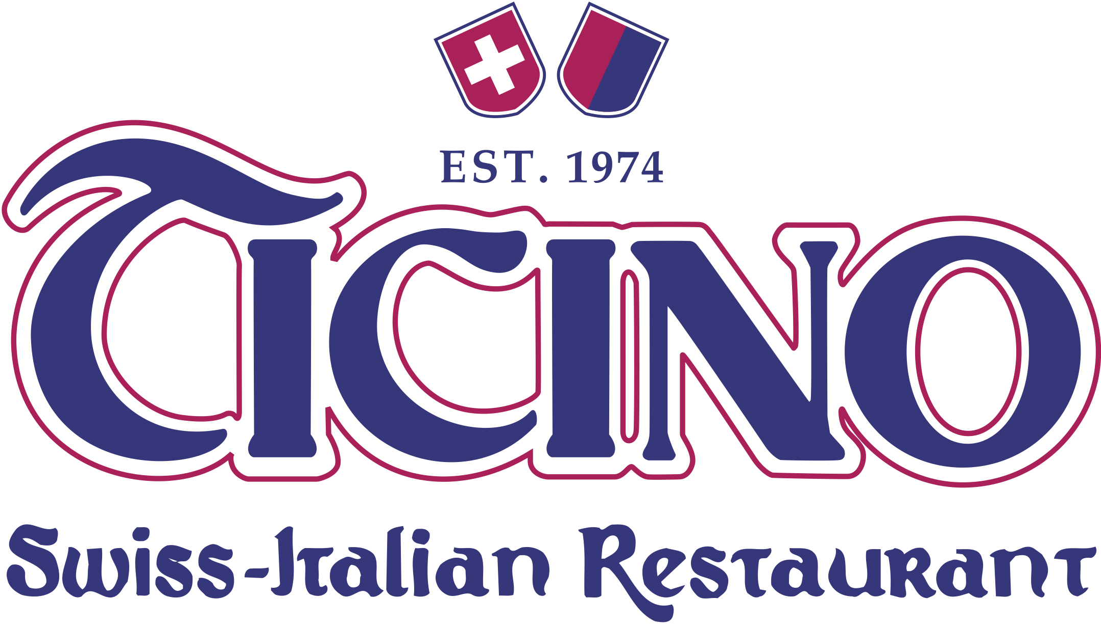
Red Wine

ARGENTINA
Malbec, Bodega Sur Los Andes, Mendoza $54

AUSTRALIA
Shiraz, Heartland, Langhorne Creek $55

CANADA
Blind Trust, Laughing Stock, Okanagan, BC VQA $75
Cabernet Sauvignon, Black Sage, Okanagan, BC VQA $64
Merlot, Sandhill, Okanagan, BC VQA $59
Pinot Noir, Haywire, Okanagan, BC VQA $62
Syrah, Daydreamer, Okanagan, BC VQA $82

CHILE
Carménère, Mayu, Gran Reserva $58
Cabernet Sauvignon, Tarapaca, Gran Reserva $57

FRANCE
Châteauneuf-du-Pape, Le Vieux Donjon $99
Château Lanessan, Delbos-Bouteiller, Haut-Médoc $79
Côtes du Rhône, Domaine Nicolas Boiron $57
Moulin-à-Vent, Château des Jacques $67
Louis Jadot (Beaujolais)

ITALY
Amarone Classico, Masi $99
Amarone Classico, Masi, ½ bottle (375ml) $59
Amarone Classico della Valpolicella, $135
Capitel Monte Olmi, Tedeschi
Barolo, Serradenari, La Morra $116
Brunello di Montalcino, Azienda Agricola La Torre $110
Primitivo, Peucetico, Coppi, Puglia $57
Ripasso, Zenato, Valpolicella $65

SPAIN
Tinto Reserva, Ochoa, Navarra $64

USA
Pinot Noir, Duck Pond, Oregon $69

Wine by the Glass
(6oz. pour)

White
Sauvignon Blanc, Sumac Ridge, Okanagan BC VQA
$13. glass ~ $35. ½ litre
Chasselas (Swiss-style), St-Hubertus, Okanagan, BC VQA
$15. glass ~ $39. ½ litre
Pinot Grigio, Santa Margherita, Italy
$14. glass ~ $37. ½ litre

Rosé
Frizzante, St-Hubertus, Okanagan Valley, BC VQA
$14. glass ~ $37. ½ litre

Red
Cabernet Sauvignon, Tarapaca, Chile
$15. glass ~ $39. ½ litre
Great Canadian Red, St-Hubertus, Okanagan, BC VQA
**This wine is a tribute to the first grapes used in the beginning of wine making in the Okanagan Valley**
$13. glass ~ $35. ½ litre
Sangiovese, Monte Antico, Italy
$14. glass ~ $37. ½ litre

Bubbles
White Effervescence, Evolve, Okanagan BC VQA, Canada
$14. glass

House Wine
White: Italian Trebbiano di Romagna
Red: Italian Merlot delle Venezi
Rosé: Californian White Zinfandel, Robert Mondavi

Glass(6oz.): $11
½ Litre: $30
1 Litre: $54

